**Entity-Relationship (ER) diagram**

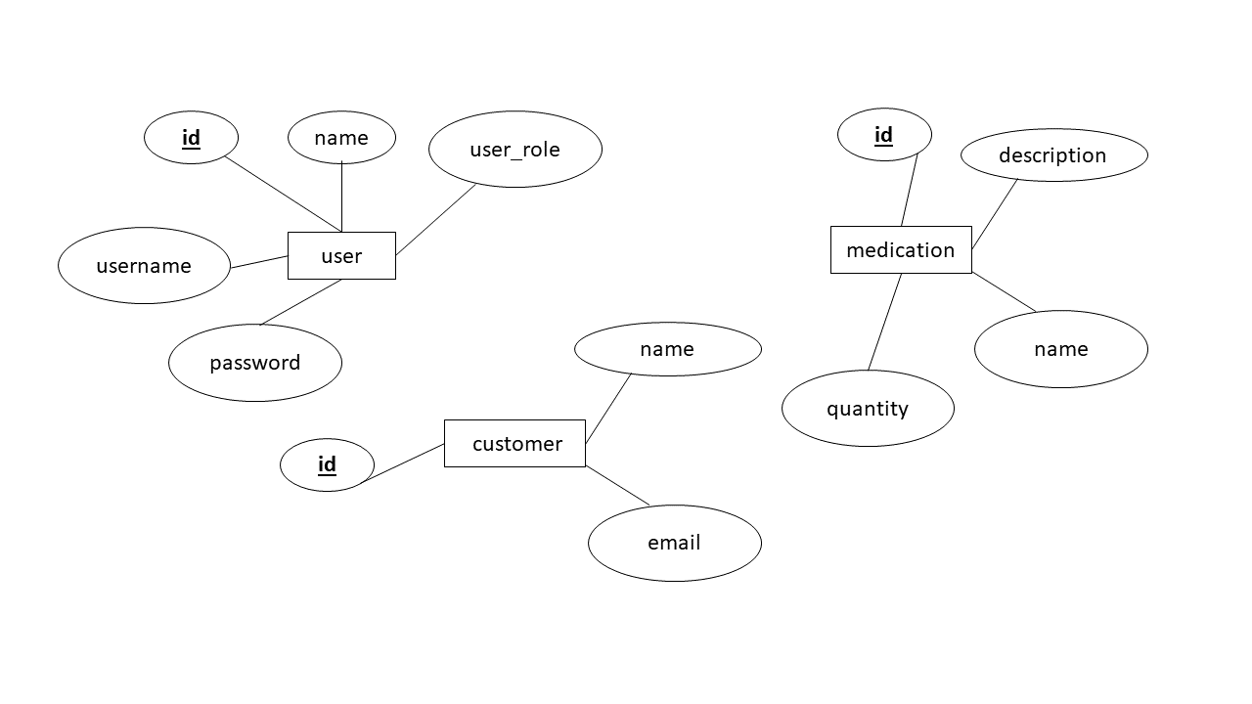

**Models:**

**User.php**

<?php

namespace App\Models;

use Illuminate\Database\Eloquent\Model;

class User extends Model

{

protected $fillable = ['name', 'username', 'password', 'user_role'];

}

**Medication.php**

<?php

namespace App\Models;

use Illuminate\Database\Eloquent\Model;

class Medication extends Model

{

protected $fillable = ['name', 'description', 'quantity'];

}

**Customer.php**

<?php

namespace App\Models;

use Illuminate\Database\Eloquent\Model;

class Customer extends Model

{

protected $fillable = ['name', 'email'];

}